**Diversifying the Volatility Risk Premium using ETF Options**

**Introduction**

Per Ilmanen (2011)[1], the short volatility risk premium (SVRP) is based on the consistent pattern of (prior) implied volatility systematically exceeding (subsequent) realized volatility. This premium reflects the insurance-like nature of options, where risk-averse investors consistently overpay relative to actuarial fair value for portfolio protection. This tendency creates reliable opportunities for volatility sellers willing and able to bear infrequent c

In equities, the primary assets that historically have been used to capture the SVRP have been market-wide indexes, like the S&P 500 (or SPY) in the United States. Various instruments are used, including variance swaps, short straddles, and others, depending on the size of the trade and the capabilities of the trader. However, there has been limited systematic examination of the properties and magnitude of the SVRP in the broader universe of exchange-traded funds. This represents a significant gap, as the explosive growth of the ETF market has created numerous liquid options markets across diverse asset classes, sectors, and geographies.

In this note we examine the SVRP using short delta hedged straddles on a variety of major ETFs. Our set of ETFs span various equity sectors, international markets, fixed income, and commodities. Our data sample of option prices is sourced from ORATS since 2015.

Our results confirm the existence and magnitude of volatility risk premiums in the ETFs, with Sharpe ratios rivaling those of indexes quoted from prior studies. Results are especially strong when strategies are aggregated into composites. Forinstance, an equally-weighted composite of ETF strategy returns earns an annualized Sharpe ratio of approximately 1.0, with correlation to the comparable strategy on SPY of 0.7 and SPY underlying of 0.5. Preliminary results on alternative weighting schemes suggest little incremental benefit from the use of correlations in forming the composite. Of course, SVRP return streams from ETFs are still punctuated by periodic crashes, which may limit the usefulness of such strategies.

This research and our results are preliminary. Areas for further research include transaction costs, longer option data samples, and other methods and instruments of capturing the SVRP.

1. **ETF Universe Characteristics**

Our analysis focuses on 19 highly liquid ETFs spanning multiple asset classes and investment styles. Table 1 provides detailed characteristics of these ETFs, which serve as the foundation for our volatility premium analysis. We use SPY (SPDR S&P 500 ETF) as a benchmark comparator, representing the traditional broad market volatility premium documented in the literature.

**Table 1: ETF Characteristics**

| **Ticker** | **ETF Name** | **Asset Class** | **Inception Date** | **AUM ($B)\*** | **Expense Ratio** | **Primary Exposure** |
| --- | --- | --- | --- | --- | --- | --- |
|  |  |  |  |  |  |  |
| **GLD** | SPDR Gold Trust | Commodities | 2004-11-18 | $56.8 | 0.40% | Gold Bullion |
| **XLK** | Technology Select Sector | US Equity Sector | 1998-12-16 | $51.2 | 0.10% | Technology Sector |
| **IWM** | iShares Russell 2000 | US Equity | 2000-05-22 | $62.4 | 0.19% | Small-Cap Equity |
| **EFA** | iShares MSCI EAFE | International Equity | 2001-08-14 | $85.1 | 0.32% | Developed International |
| **XLF** | Financial Select Sector | US Equity Sector | 1998-12-16 | $40.2 | 0.10% | Financial Sector |
| **TLT** | iShares 20+ Year Treasury | Fixed Income | 2002-07-22 | $24.8 | 0.15% | Long-Term Treasuries |
| **DIA** | SPDR Dow Jones Industrial | US Equity | 1998-01-20 | $31.4 | 0.16% | Dow Jones Industrial |
| **IEF** | iShares 7-10 Year Treasury | Fixed Income | 2002-07-22 | $16.9 | 0.15% | Intermediate Treasuries |
| **LQD** | iShares iBoxx Investment Grade | Fixed Income | 2002-07-22 | $34.2 | 0.14% | Investment Grade Corporate |
| **XLE** | Energy Select Sector | US Equity Sector | 1998-12-16 | $28.7 | 0.10% | Energy Sector |
| **XLY** | Consumer Discretionary Select | US Equity Sector | 1998-12-16 | $19.6 | 0.10% | Consumer Discretionary |
| **XLI** | Industrial Select Sector | US Equity Sector | 1998-12-16 | $16.8 | 0.10% | Industrial Sector |
| **XLU** | Utilities Select Sector | US Equity Sector | 1998-12-16 | $15.2 | 0.10% | Utilities Sector |
| **EEM** | iShares MSCI Emerging Markets | International Equity | 2005-04-07 | $25.4 | 0.68% | Emerging Markets |
| **SLV** | iShares Silver Trust | Commodities | 2006-04-21 | $13.1 | 0.50% | Silver Bullion |
| **HYG** | iShares iBoxx High Yield | Fixed Income | 2007-04-04 | $18.9 | 0.49% | High Yield Corporate |
| **XLP** | Consumer Staples Select | US Equity Sector | 1998-12-16 | $14.8 | 0.10% | Consumer Staples |
| **XLB** | Materials Select Sector | US Equity Sector | 1998-12-16 | $10.1 | 0.10% | Materials Sector |

Our ETF universe represents approximately $810 billion in combined assets under management. The selection spans the US Equity Broad Market (2 ETFs): IWM, DIA, US Equity Sectors (9 ETFs): XLK, XLF, XLE, XLY, XLI, XLU, XLP, XLB, International Equity (2 ETFs): EFA, EEM, Fixed Income (4 ETFs): TLT, IEF, LQD, HYG, and Commodities (2 ETFs): GLD, SLV. Note that we avoid usage of QQQ as a diversifier, as it is too closely related to SPY. Throughout, we use SPY as a benchmark comparator. It incepted in 1993, has AUM of $516.8B, and an expense ratio of 0.09%

.

1. **Data**

We utilize comprehensive daily option data from ORATS (Option Research & Technology Services) covering approximately 10 years of trading history. The dataset includes end-of-day option prices for all available strikes and expirations; implied volatilities calculated using market-standard Black-Scholes methodology with dividend adjustments; option Greeks including delta, gamma, theta, and vega; volume and open interest data for liquidity assessment; as well as ETF prices and dividends.

Our sample begins with the earliest available option data for each ETF, with most series extending from 2015 through 2024, providing sufficient history to analyze volatility premiums across multiple market cycles including the COVID-19 crisis, Federal Reserve policy transitions, and various sector-specific volatility events. Of course, this excludes important tail events, such as the 2008 Great Financial Crisis, and the Crash of October 1987.

**3. Delta-hedged short straddles**

Institutional investors can capture short volatility premiums through a variety of systematic transactions, each with distinct risk-return characteristics and implementation considerations. For simplicity, in our analysis we use delta-hedged short straddles. This approach sells a call and put option at the same (at-the-money) strike price with one month until expiration, collecting premium from both options, then delta-hedging (negating the delta of the option package) daily through expiration. Below are results for our 10 year sample for all tickers, for an equally weighted composite of all ETF tickers, and for comparison the same strategy implemented on SPY, and also the returns of SPY as an undelyer.

**4. Comparison of implied and realized volatility**

Following the established literature, we calculate the implied-realized volatility spread (IRVS) as the difference between the 30 day ATM implied volatility (based on the Black-Scholes model), and subsequent 30 day realized volatility.

A consistently positive IRVS indicates a persistent volatility premium, suggesting profitable opportunities for volatility sellers. Figures 1 and compare the IRVS (and its components) for SPY and GLD.

Both panels show similar patterns. First, the IRVS is consistently positive, often more than 80% frequency. Second, periods of excess (realized) volatility, while infrequent, are severe. For instance, during market stress periods, such as March 2020, the spread turns negative and widens significantly. In our sample the spread returns to its normal (positive) level, even if both implied (and realized) remain comparatively elevate

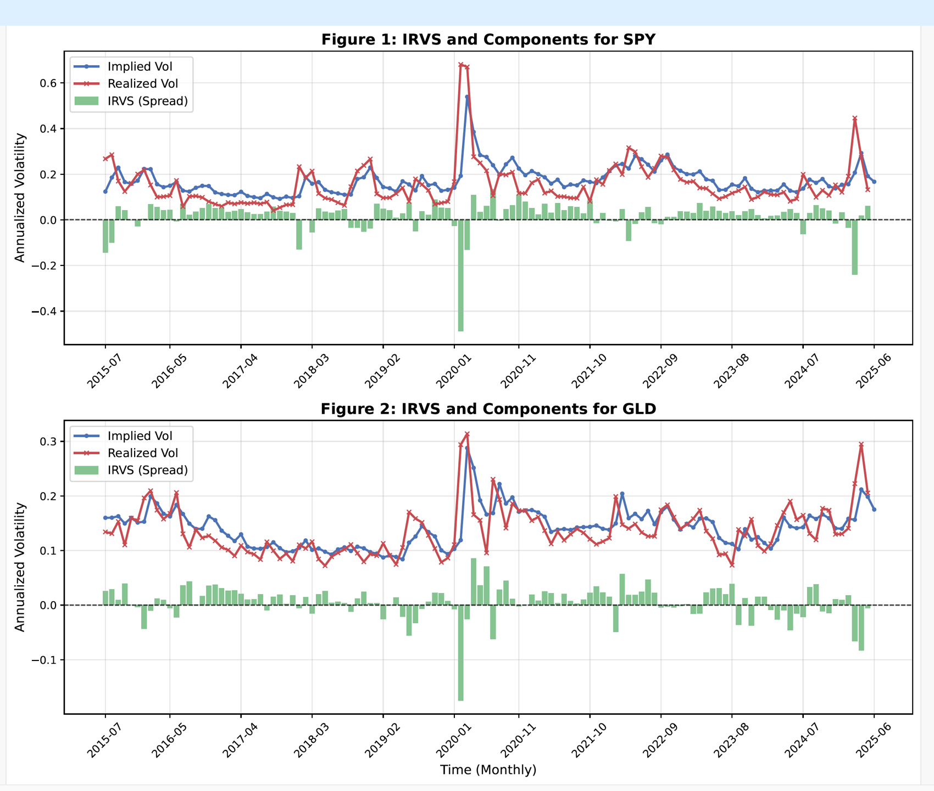

Here is a summary of the IRVS components for each ticker and for an equally weighted composite.

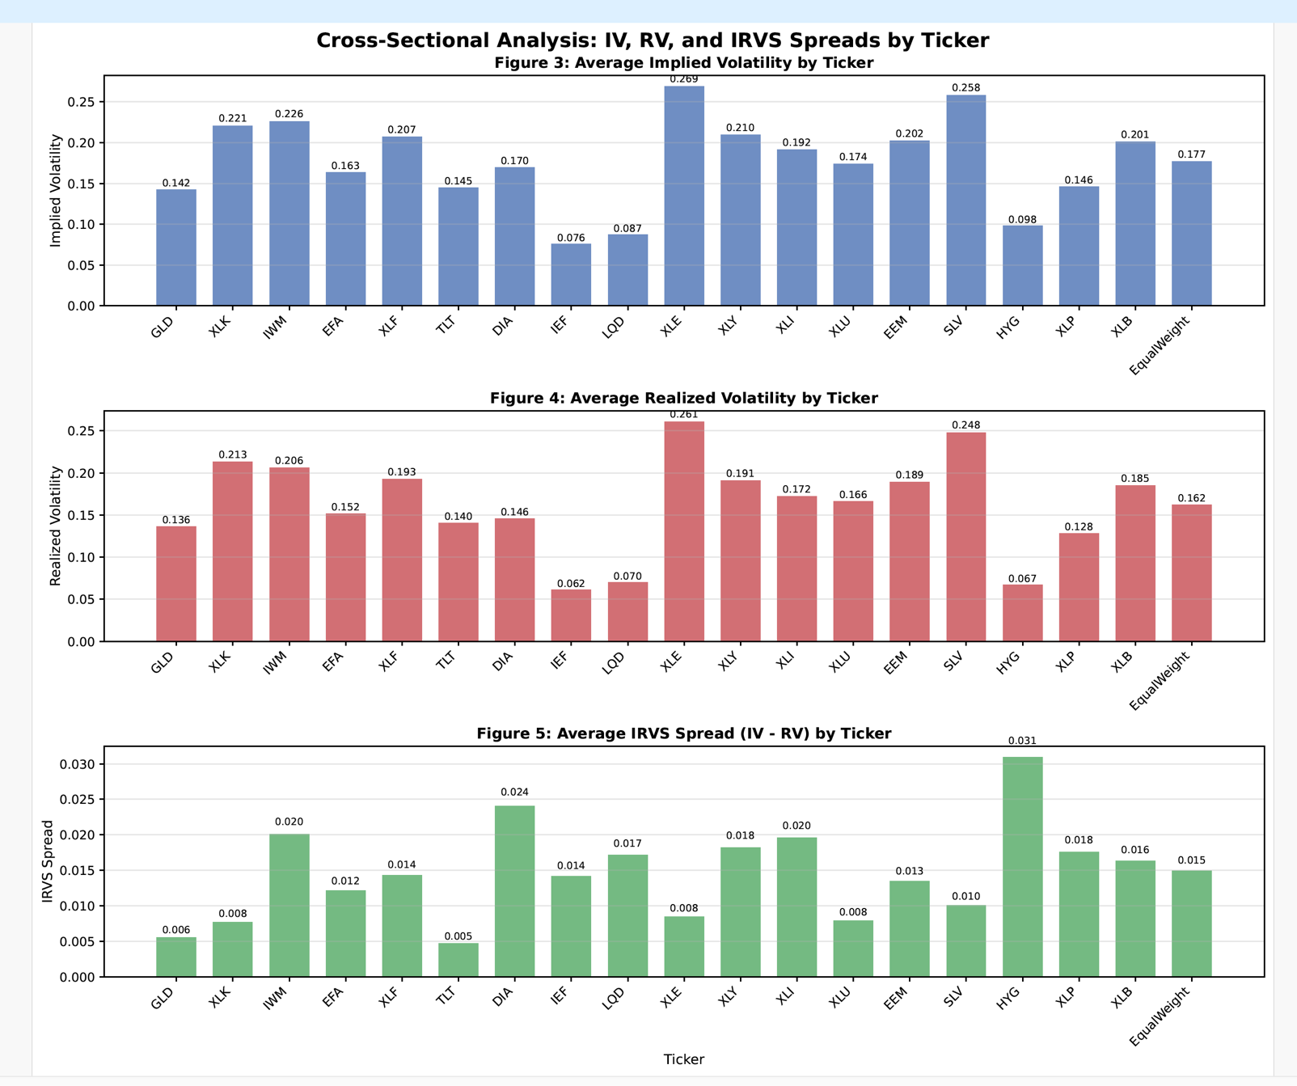

Clearly the IRVS is consistently positive across most ETF tickers spanning disparate asset classes, even if spreads and their components vary.

**5. Strategy results**

Figures 6 through 13 provide our results in chart form.

Figures 6 through 8 show the annualized mean, standard deviation, and Sharpe ratios for the short volatility selling strategies implemented on the ETFs, along with an equally weighted composite of the ETF strategies, the strategy implemented on SPY, and the returns of the SPYunderlyer itself. We elected to use an equal weighting scheme because of its simplicity but clearly, owing to variation in volatilities and correlations, could be improved upon. The performance varies, but on average the Sharpe ratios (SRs) appear to be superior for ETFs compared to SPY. This is especially true for HYG (which may be due simply to sampling variation with various underlyers), and also for the equally weighted composite of all ETF strategies whose SR is 1.01 compared to that of SPY at 0.45.

Figures 9 and 10 show skew and kurtosis. While there is again variation across underlyers (and an anomaly in the case of IEF), all strategies entail negative skew. The disparity in average magnitude is especially pronounced compared to SPY underlying.

An analogous story is told by the kurtosis figures. This measure of tail risk is outsized, even nightmarish, for the option selling strategies (with again a single extreme anomaly, here in the case of XLF), and they are especially outsized relative to the sole underlyer surveyed, SPY. This emphasizes the need for pooling and diversification to reduce the effecti idiosyncratic outliers.

In lieu of a voluminous correlation matrix, Figures 11 and 12 show correlations with the SPY strategy and also SPY underlyer. Clearly the average correlation is significant and subjectively high at 0.71, although diversification benefits are still possible.

Finally Figure 13 shows a growth-in-NAV comparison of two strategies, one the equally-weighted strategy of all tickers, the other the strategy on SPY. The high correlation is evident – but so is the outperformance associated with the ETF strategy.

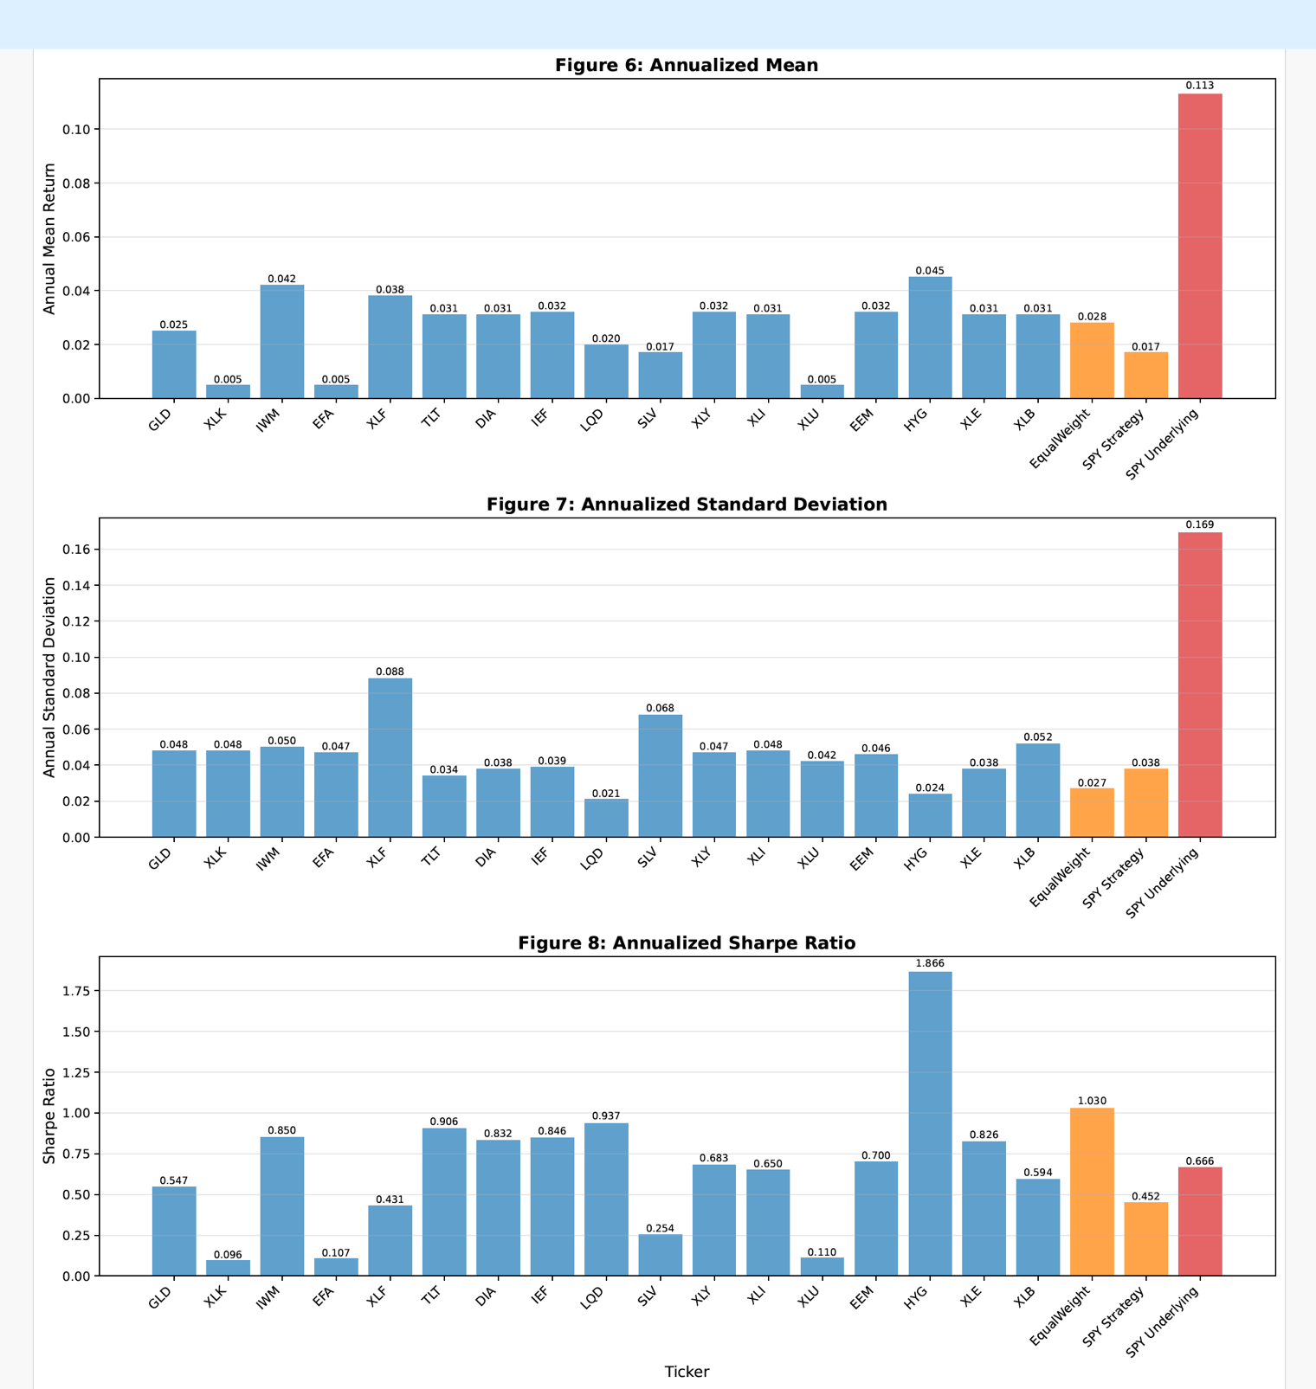

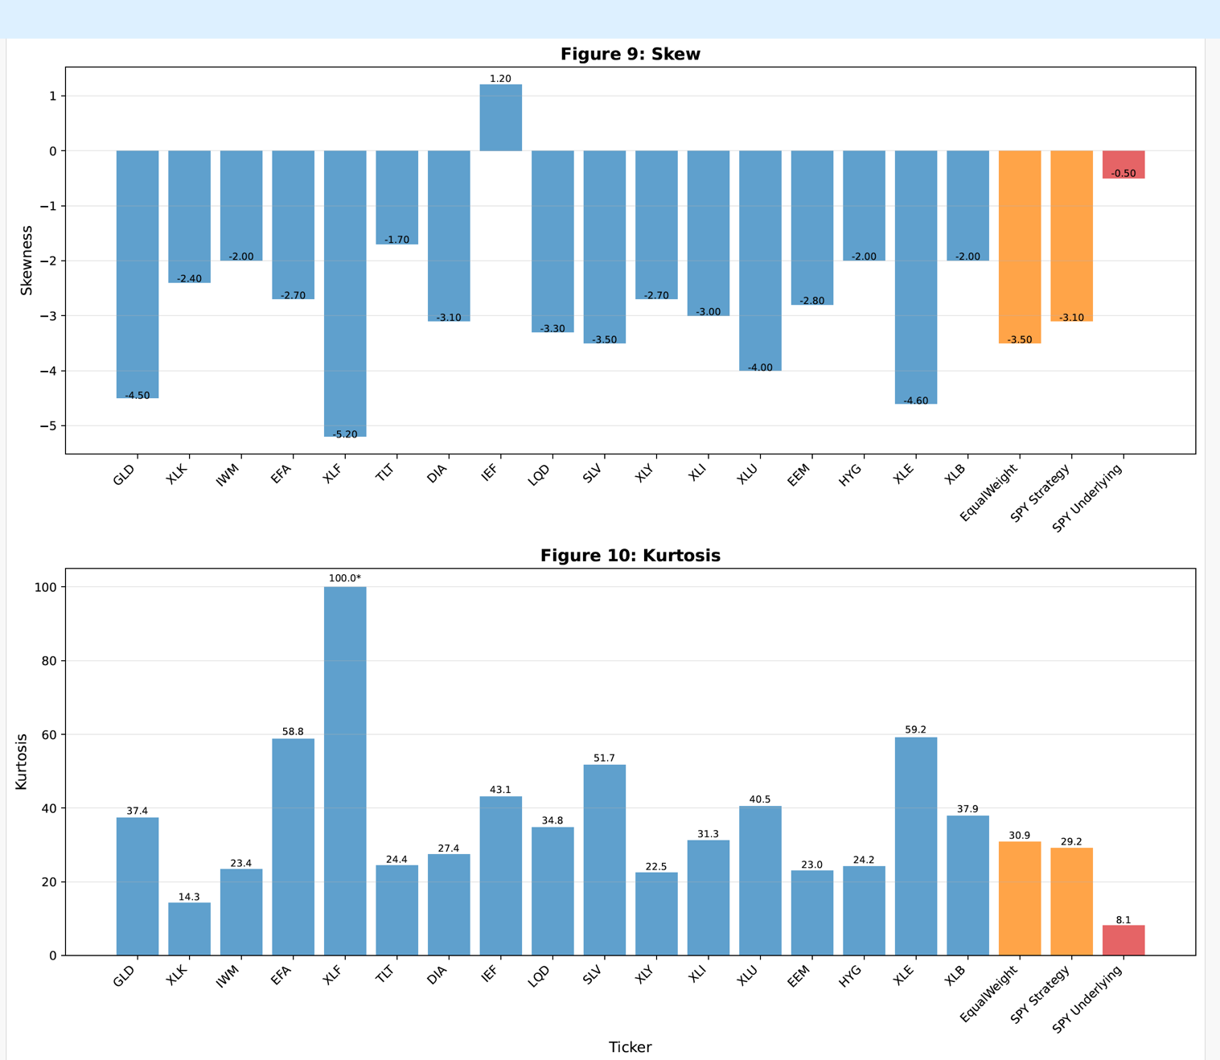

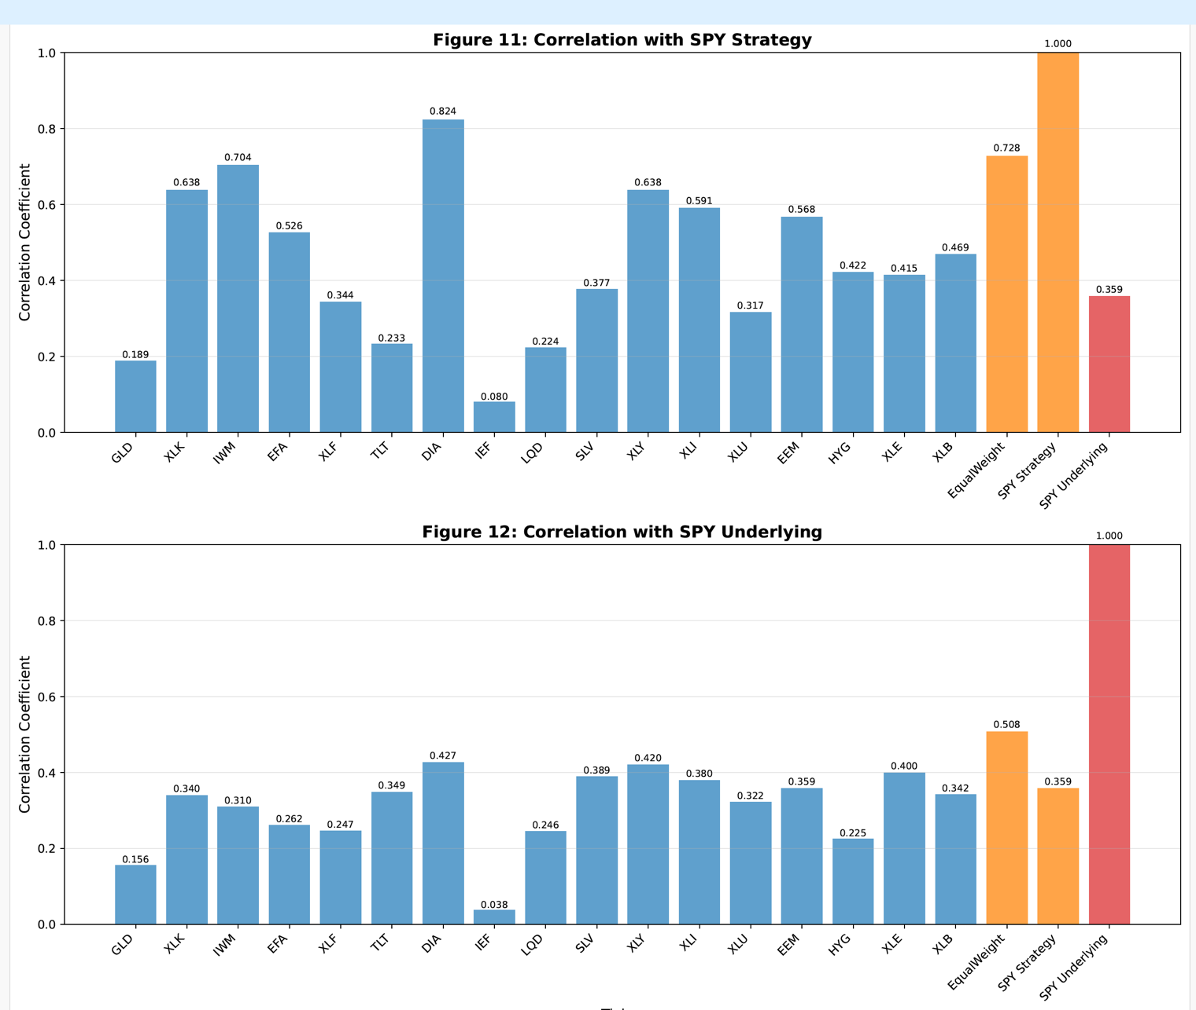

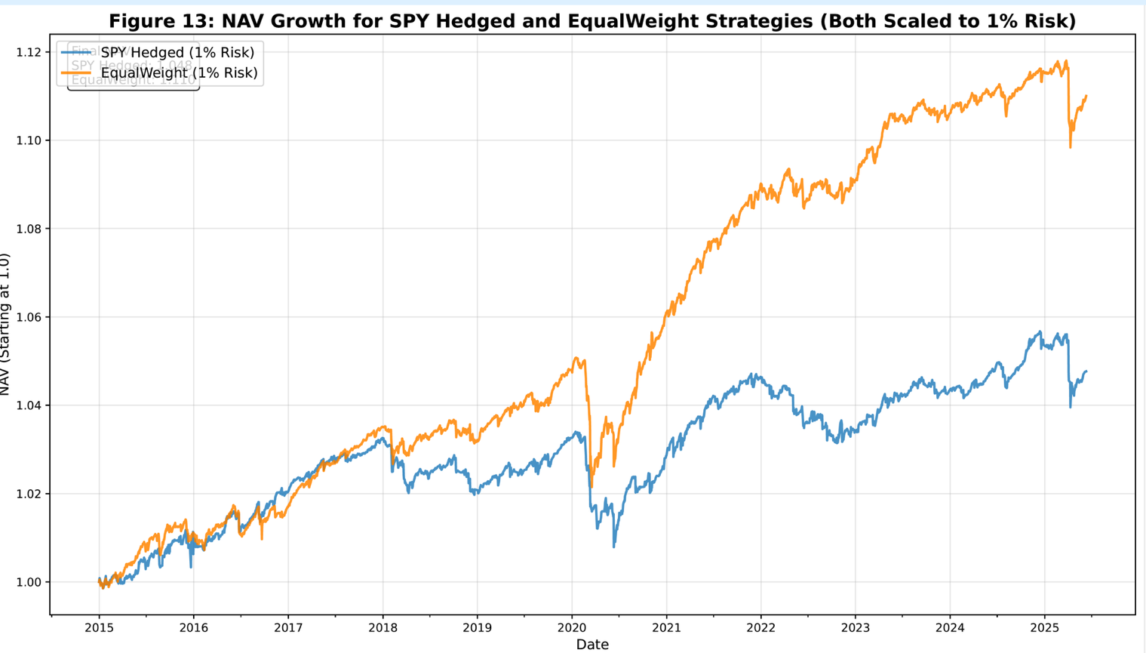

**6. Additional Considerations and Future Research**

The short delta-hedged straddle that offers exposure to volatility dynamics and is relatively straightforward to implement. However, given the significant tail risk of these strategies, both individually and in the composite, other defined risk approaches (such as credit spreads or iron flies) may be more attractive alternatives

Liquidity remains an important consideration, since multi-leg strategies depend on adequate bid-ask spreads across several strikes, and ETF option liquidity, while impressive, is often markedly less than that of SPY.

Transaction costs must also be weighed carefully, as option strategies typically entail higher implementation costs relative to simpler strategies based on primary instruments.

Portfolio integration is influenced by correlations with existing holdings, and sector-specific ETFs may provide opportunities to complement or hedge current exposures.

Finally, alternative weighting schemes—such as market-cap weighted, volatility-adjusted, and covariance-based composites—warrant analysis to assess their relative effectiveness in supporting the strategy.

1. Ilmanen, A. (2011). *Expected Returns: An Investor's Guide to Harvesting Market Rewards*. John Wiley & Sons. [Particularly Chapter 15: Volatility as an Asset Class]